Analysis of Teacher Performance on
Learning Managment in Primary School

Authors :
Roos. M. S. Tuerah

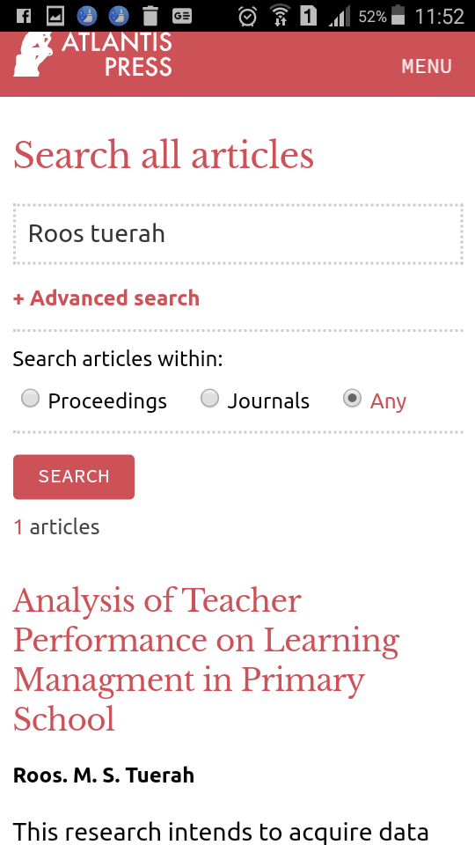

Part of series : Advances in Social Science, Education and Humanities Research
Publication date : November 2017
ISBN : 978-94-6252-419-4
ISSN : 2352-5398
DOI : doi:10.2991/icset-17.2017.171
Part of series : ASSEHR, ISSN: 2352-5398, volume: 118

https://www.atlantis-press.com/proceedings/icset-17/25886669

Differentiated Learning Model For Student With Reading Difficulties
Authors :
Aldjon Dapa

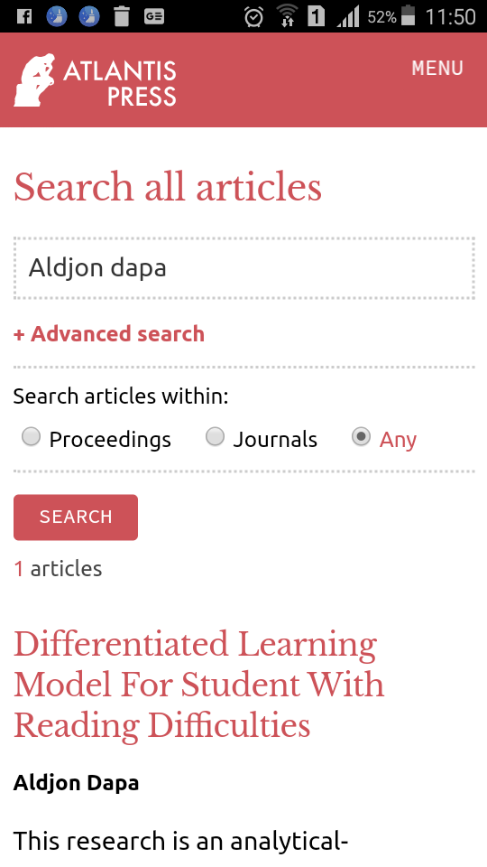

Part of series : Advances in Social Science, Education and Humanities Research
Publication date : November 2017
ISBN : 978-94-6252-419-4
ISSN : 2352-5398
DOI : doi:10.2991/icset-17.2017.157
Part of series : ASSEHR, ISSN: 2352-5398, volume: 118

https://www.atlantis-press.com/proceedings/icset-17/25886655

